

Melkbosstrand High School
Grade 11 | Computer Applications Technology |  | Term 2  28 May 2026
Time: 3 hours | TASK 3  Practical Exam |  | Marks: 120
Examiner: R. Rabe |  | Moderator: F Pretorius

INSTRUCTIONS AND INFORMATION

1.  2.  3.  4.  5.  6.  7.  8.  9.  10.  11.  12. | Owing to the nature of this three-hour examination, it is important to note that, even if you complete the examination early, you will NOT be permitted to leave the examination room until all the administrative functions associated with the examination have been finalised. During the examination, normal rules regarding leaving the examination room apply.  Type your Name and Surname in the header of EVERY document that you create or save, where applicable.  The data files can be found in the Exam Data folder on the network or a local computer. If you are working on the network, you must follow the instructions provided by the invigilator.  A copy of the master files will be available from the invigilator. Should there be any problems with a file, you may request another copy from the invigilator.  This question paper consists of SEVEN questions.  Answer ALL the questions.  Ensure that you save each document using the file name given in the question paper. Save your work at regular intervals as a precaution against possible power failures.  Read through each question before answering or solving the problem. Do NOT do more than is required by the question.  At the end of the examination, you should make sure that ALL the files are saved on the network as explained to you by the invigilator/teacher. Make absolutely sure that all files can be read. Do NOT save unnecessary files/folders. Do NOT hand in duplicate answer files/folders.  The separate information sheet which has been provided with this question paper MUST BE COMPLETED AFTER THE THREE-HOUR EXAMINATION SESSION. Hand it to the invigilator at the end of the examination.  During the examination you may consult the offline help functions of the programs that you are using. You may NOT use any other resource material.  Unless instructed otherwise, use formulae and/or functions for ALL calculations in questions involving spreadsheets. Use absolute cell references only where necessary to ensure that formulae are correct when you copy them to other cells in a spreadsheet.
13  14.  15.  16.  17. | NOTE: All formulae and/or functions should be inserted in such a manner that the correct results will still be obtained even if changes are made to the existing data.  If data is derived from a previous question that you could not answer, you should still proceed with the questions that follow.  In all questions involving word processing, the language should be set to English (South Africa). The paper size is assumed to be A4 Portrait, unless instructed otherwise.  Ensure that the regional settings are set to South Africa and date and time settings, number settings and currency settings are set correctly.  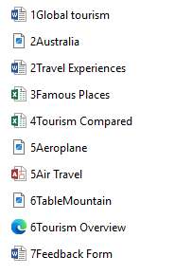  The examination folder that you receive with this question paper will contains the files listed below. Ensure that you have all the files before you begin this examination.
Exam Data

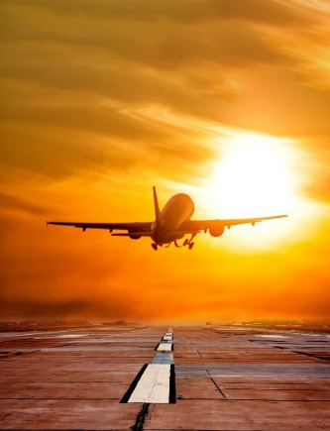
QUESTION 1: WORD-PROCESSING
SCENARIO: GLOBAL TOURISM
To travel is to discover that the world is far bigger—and kinder—than you imagined, and every journey leaves a footprint on your soul.
Open the 1Global tourism word-processing document which looks at how global tourism started and its significance today.
1.1 | Change the title of the document to display as follow:    NOTE:  - Assign the Title style to the text.  - Apply an offset to the bottom right shadow effect to the text. | (3)
1.2 | Modify the Heading 1 style to display:  - In the font Comic Sans.  - Underlined. | (2)
1.3 | Add your name and surname as author to the document info. | (1)
1.4 | Use a word-processing feature to replace all the occurrences of the word ‘visitors’ with ‘guests’ in bold and underlined. | (4)
1.5 | Locate the picture under the heading ‘Introduction’ and set the picture to:  - Display in full colour.  - Display 6 cm high and 8 cm wide.  - Apply any mirror effect to the picture.  - Add appropriate text to the picture to assist users with visual impairments to know what is being displayed. | (5)

1.6 | Insert page numbers to the document to display as shown in screenshot below:  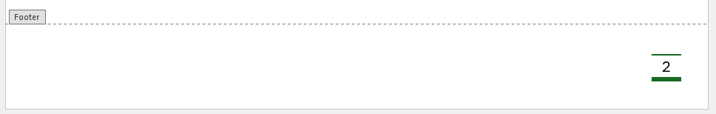  NOTE:  - No page number must be displayed on the first page. | (5)
Save and close the 1Global Tourism word-processing document. |  | [20]

QUESTION 2: WORD-PROCESSING
Open the 2Travel Experiences word-processing document.
2.1 | Remove page break on the first page. | (1)
2.2 | Locate the first letter (“T”) of the paragraph under the heading ‘Transport Troubles Around the World’ and display it:  - In the margin.  - In the font Arial Black, colour red.  - 0.5 cm away from the text.  - To cover the whole paragraph.  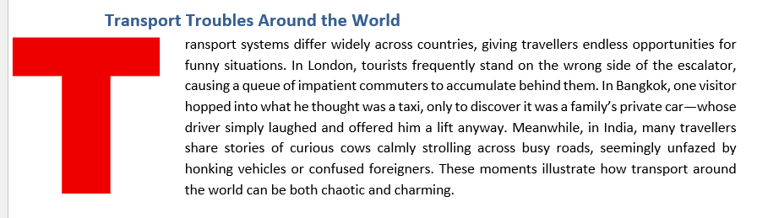 | (5)
2.3 | Edit the table under the heading ‘Travel Experiences Around the World’ to display as the screenshot below:  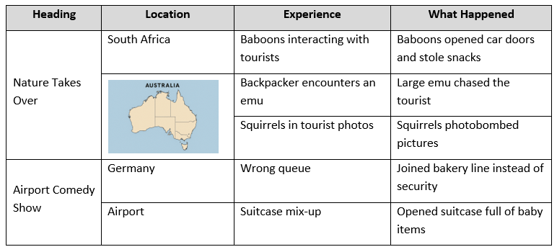  - The image 2Australia.png can be found in the examination data folder. | (5)
2.4 | Create a new style named ‘TopLabel’ as follow:  - Based on the ‘Title’ style.  - With a bottom left shadow text effect.  - With a border line at the bottom. | (4)
 |  | [15]

QUESTION 3: SPREADSHEETS
_{NOTE:}
- Use formulae and/or functions for ALL calculations in the spreadsheet.
- Use absolute cell references ONLY where it is required by the question to ensure that formulae are correct when you copy it to other cells in the spreadsheet.
- Insert formulae and/or functions in such a manner that the correct results will still be obtained even if the existing data changes.
- Should you need to use building blocks, use the allocated space in the spreadsheet.
Open the 3Famous Places spreadsheet which contains data on the number of visitors to some of the most famous places in the world.
Work in the Famous Places sheet.
3.1 | Apply an appropriate number format to the data in column E. |  | (1)
3.2 | Use formatting to round the data in column F to show with two decimals. |  | (1)
3.3 | Apply a spreadsheet feature to fix row 1 at the top of the sheet whenever you scroll down. |  | (1)
3.4 | The revenue generated for each place is calculated by multiplying the entry fee by the number of annual visitors.  Insert a formula in cell E6 to calculate the entry fee to the Taj Mahal. |  | (3)
3.5 | Use conditional formatting in column C to indicate the number of annual visitors by the following categories:  - Indicate all cells with more than 10 million visitors with a green arrow.  - All cells with less than 5 million visitors should be indicated by a red arrow.  - All other cells should be indicated by an orange arrow. |  | (5)
3.6 | Insert a formula in cell C33 to calculate the total number of visitors to the following places:  - Eiffel Tower, The Forbidden City in China and the Burj Khalifa in UAE.  Show your answer in millions. |  | (3)
3.7 | Insert a formula in cell C34 to display the number of annual visitors to the Sydney Opera House into the full amount (e.g., 7.2 → 7 200 000). |  | (3)
3.8 | Correct the error in cell C35 to display the thirtieth (30th) smallest entry fee in column E. |  | (1)
3.9 | The function in cell C36 is meant to find the highest entry fee paid at any place. Rectify the function to display the correct answer of R2446.04. |  | (1)
3.10 | Insert a function in cell C37 to determine the number of places declared as UNESCO Heritage sites. |  | (3)
Save your work in the Famous Places sheet.
Work in the Arrivals sheet.
3.11 | Apply the following formatting to the sheet:
 | 3.11.1 | Change the sheet name to ‘Arrival (Africa South)’ and set the sheet tab colour as yellow. | (2)
 | 3.11.2 | Sort the worksheet by year so that the most recent year appears first. | (2)
 |  |  | [26]
QUESTION 4: SPREADSHEETS
_{NOTE:}
- Use formulae and/or functions for ALL calculations in the spreadsheet.
- Use absolute cell references ONLY where it is required by the question to ensure that formulae are correct when you copy it to other cells in the spreadsheet.
- Insert formulae and/or functions in such a manner that the correct results will still be obtained even if the existing data changes.
Open the 4Tourism Compared spreadsheet which contains data air passengers’ totals for six different countries.
Work in the Sheet 1 sheet.
4.1 | In cell D20, enter a formula using an IF function to display:  - "High" if the number of arrivals to Australia for the year 2020 is greater than 50 million.  - "Low" if the number of arrivals for the same year is less than or equal to 50 million. | (3)
Save your work in the Sheet1 sheet.

Work in the Fatal Accidents sheet.
4.2 | Create a graph as shown below to illustrate the difference between passenger hijackings and fatal accidents for the years 1991 and 2000:  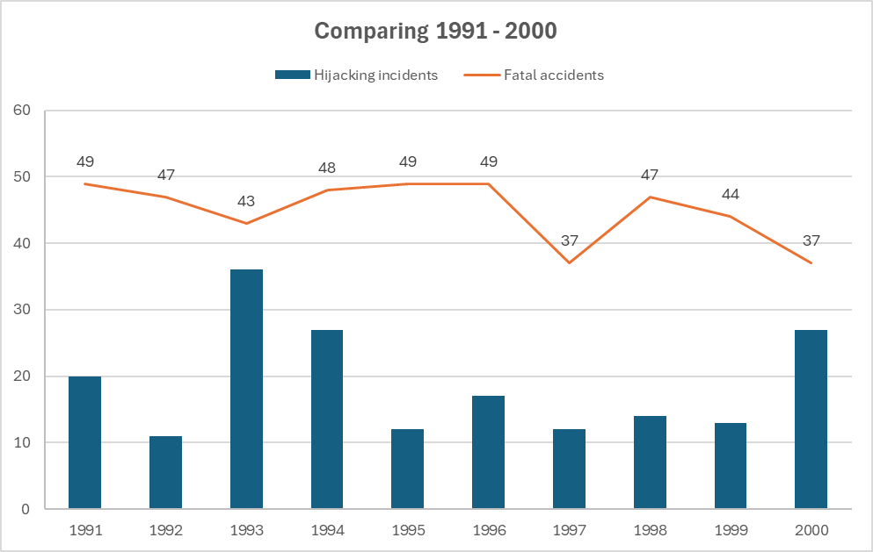  NOTE:  - Add appropriate titles to the horizontal and vertical axes. | (6)
Save and close the 4Tourism Compared spreadsheet.
 |  | [9]

QUESTION 5: DATABASE
Open the 5Air Travel database which contains statistics on passenger air travel to different tourist destinations across the world.
5.1 | Open the tblPlaces table in Design View.
 | 5.1.1 | Set an appropriate field size for the field Code. | (1)
 | 5.1.2 | - Change the name of the field UNESCO_World_Heritage to ‘Heritage?’ and assign an appropriate data type to this field. | (2)
 | 5.1.3 | - Assign a suitable field as the primary key of this table. | (1)
 | 5.1.4 | Apply a setting to the Region field so that the user must make an entry in it. | (1)
 | 5.1.5 | Set the Year_Built field so that the value 2026 will automatically appear when a new entry is made. | (1)
 | 5.1.6 | Insert an input mask to the Code field so that the correct data format can be entered:  Example: LM-026 | (4)
Save and close the tblPlaces table.
5.2 | Create the following form, named frm5_2 based on the tbl5_1 table:  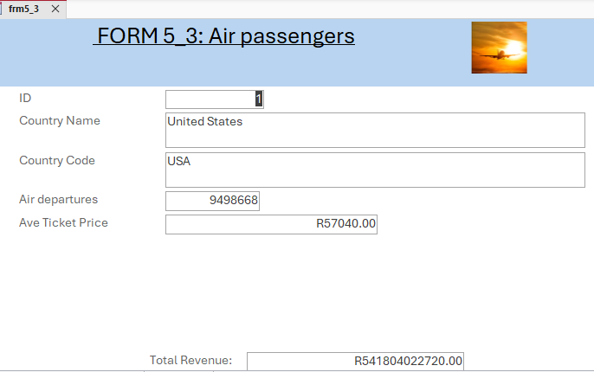  FORM 5_2: Air passengers  NOTE:  - Enter a calculation in the form footer to display the total revenue generated by each country. Show total as currency.  - Image 5Aeroplane.png can be found in examination data folder.  HINT: Total Revenue = Air departures x Average Ticket Price. |  | (5)
Save and close frm5_2 form.
5.3 | Open the qry5_3 query, based on the tbl5_1 table, in Design View.  Modify the query to:  - Display countries with the average ticket price of equal to and more than R50 000.00.  - Show the fields Country Name, Country Code and Ave Ticket Price.  Save and close the qry5_3 query. |  | (3)
5.5 | Create a query called qry5_4 based on the tblPlaces table to display:  - All the heritage sites that are seen as a type of monument.  - Show the fields Place_Name, Type and Heritage?  Save and close the qry5_4 query. |  | (3)
5.4 | Open the qry5_5 query, based on the tbl5_1 table, in Design View.  Modify the query to display:  - All the countries from Europe where the number of arriving passengers is between 26 million and 40 million.  - The fields Country Name, Continent, Air departures and Air arrivals.  Save and close the qry5_5 query. |  | (4)
Save and close the 5Air Travel database. |  |  | [25]

QUESTION 6: HTML/WEB DESIGN
NOTE:
- You may NOT use a word processing program such as Word to answer the HTML questions.
- An HTML tag sheet has been attached for reference.
- All files needed to complete this question can be found in the examination folder.

6.1 Open the incomplete 6Tourism Overview web page in a web browser and also in a text/HTML editor (NOT a word processing program such as Word).
Complete the web page to appear as shown in the example below.
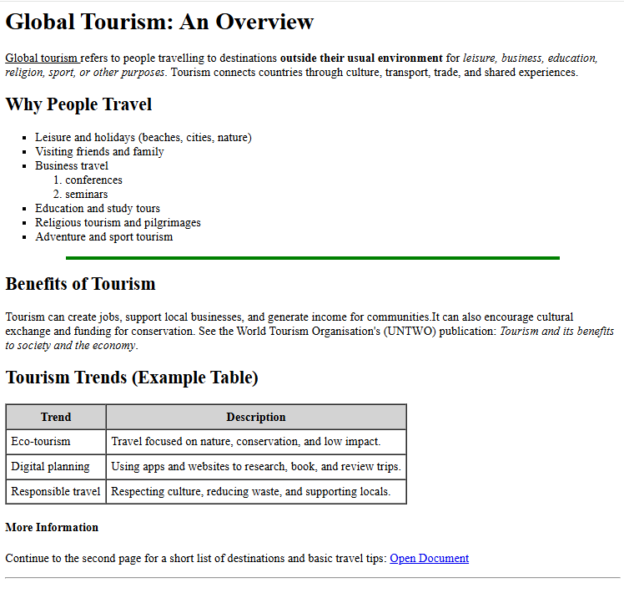

NOTE:
- Use the example on the previous page as a guideline when answering this question.
- Question numbers appear as comments in the coding to indicate where you should insert the answer(s). Do NOT delete these comments.

6.1.1 | Amend the code so that the text ‘Global Tourism’ appears in the web browser’s tab. | (1)
6.1.2 | Change the font of the heading ‘Global Tourism: An Overview’ to display in the font Verdana and colour brown. | (2)
6.1.3 | Apply editing to the paragraph below the heading to display as the screenshot below:  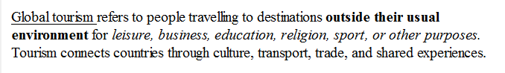 | (3)
6.1.4 | Insert a comment above the heading ‘Why People Travel’ that reads: ‘The reasons why people travel’. | (2)
6.1.5 | Edit the code to display the bulleted list to resemble the screenshot below:  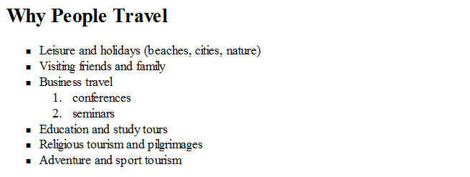 | (3)
6.1.6 | Change the green horizontal line before the heading ‘Benefits of Tourism’ to stretch across 80% of the page. | (1)
6.1.7 | Insert a line space between the horizontal line and the heading ‘Benefits of Tourism’. | (1)
6.1.8 | Apply coding to the heading ‘More Information’ to appear smaller than the other headings. | (1)
Save and close 6Tourism Overview web page.
ONE mark will be allocated for closing tags and correct nesting in both the web pages. |  | (1)
 |  | [15]

QUESTION 7: GENERAL
An electronic form was designed for visitors to complete as an indication to what activities they will be participating in.
The final feedback form should resemble the document below:
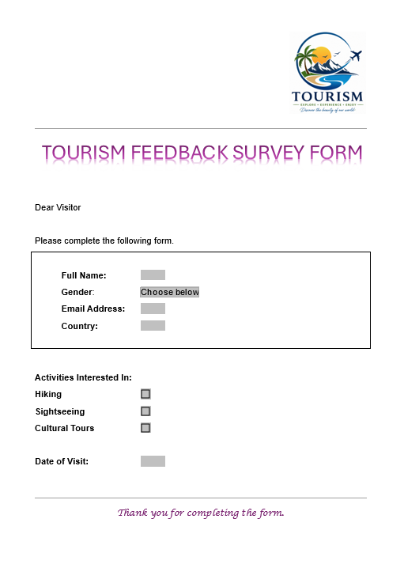

Open the incomplete 7Feedback Form document and edit the document as follow:
7.1 | Set the WordArt so that the text display in one line as shown. | (1)
7.2 | Entries to the text form field for the ‘Full Name’ must not be longer than 60 characters. | (1)
7.3 | Insert the gender form field with the following specifications:  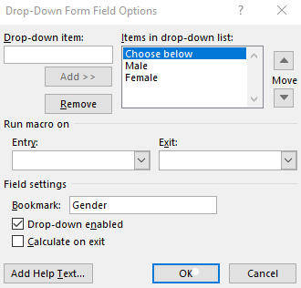 | (4)
7.4 | Add appropriate help text to the Email Address form field to guide the user to enter a valid email address, which must include the @ sign. | (1)
7.5 | Set the text form field for ‘Country’ to accept only capital letters. | (1)
7.6 | The Date text form field should display the current date in the format Wednesday, 29 April 2026. | (2)
Save and close the 7Feedback Form word-processing document.
 |  | [10]
GRAND TOTAL: |  | [120]

